1. Install NODE.JS
2. npm install -g @angular/cli
   1. npm- Node Package Manager
   2. -g – Generate
   3. Cli- command line interface
3. ng new my-first-project
   1. my-first-project is the name of our project(eg. Demo, my-app,etc.)
4. ng serve
5. start our code
6. Install bootstrap:
   1. npm install bootstrap
   2. add the .css and .js files in index.html of our code
7. Create **components**/module:
   1. ng g c navigation/ ng g m model name
      1. g generate
      2. c component
      3. navigation is the component that we have created

**NOTES**

* **LIFECYCLE OF ANGULAR**

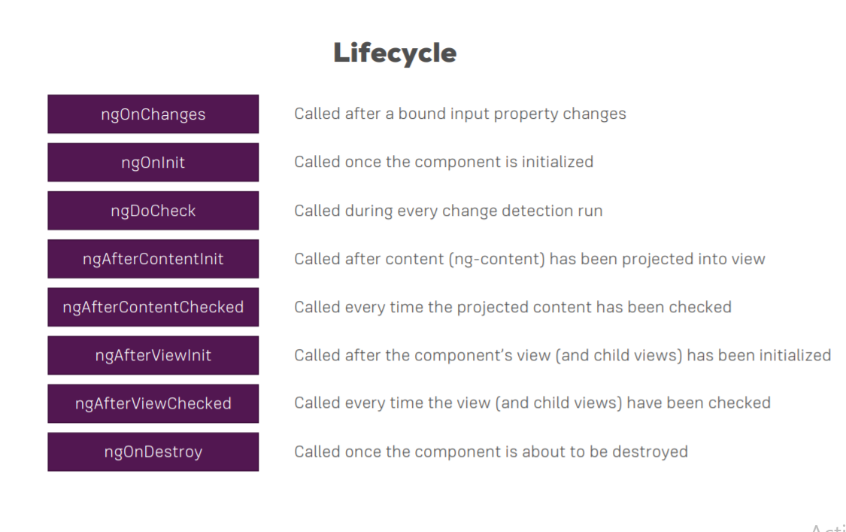

* **Model**: By suing this duplication of code is avoided eg. same js code
* **Module:** Combination of components is called module.
* 1. **Selector** - used for accessing the component  
  2. **Template/ Template URL** - contains HTML of the component  
  3. **StylesURL** - contains component-specific stylesheets
* **How does an Angular application work?**
  + **Angular.js file**
  + **Main.ts**
  + **Appmodule**
  + **Index.html**
  + **App-root**
  + **App-component.ts**

## **What are directives in Angular?**

A core feature of Angular, directives are attributes that allow you to write new HTML syntax, specific to your application. They are essentially functions that execute when the Angular compiler finds them in the DOM.  The Angular directives are segregated into 3 parts:

1. Component Directives
2. Structural Directives
3. Attribute Directives